# Wireless Network Scanning and Information Gathering

Scanning for wireless networks, gathering essential information, and analyzing available wireless access points (APs) is a fundamental skill for network administrators, penetration testers, and cybersecurity enthusiasts. The process involves discovering nearby wireless networks, capturing key details like SSID, encryption type, signal strength, and more. Below are steps and tools that can help you achieve this.

* In the first step we have enable the monitor mode . Use airmon-ng to enable monitor mode on your wireless interface.
* Command: sudo airmon-ng start wlan0

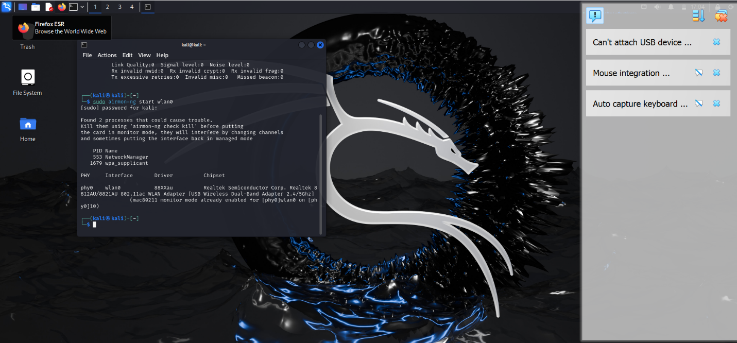

In the second step we have to scan the wireless networks

Command: sudo airodump-ng wlan0

In the third step we have to find the key information like Bssid, Essid , channel number.

Identified Network characteristics:

**BSSID**: 00:14:22:01:62:91 is the MAC address of the access point.

**Channel**: CH 6 indicates that the AP is operating on channel 6.

**Encryption**: WPA2 indicates the AP is using WPA2 encryption.

**ESSID: spectrum setup**  is the network name.

BSSID: **BSSID** stands for **Basic Service Set Identifier**. It is a unique identifier assigned to each wireless access point (AP) in a Wi-Fi network. The BSSID is typically the **MAC address** (Media Access Control address) of the AP's wireless interface. Each wireless AP in a network has its own BSSID, which helps differentiate it from other APs, even if they have the same SSID (network name).

Network management: Network administrators can monitor APs using their BSSIDs to troubleshoot or optimize network performance. It helps in identifying which AP a client is connected to, especially in networks with multiple APs sharing the same SSID.

security: During penetration testing, BSSID allows attackers or security professionals to target specific APs. It is particularly useful when working with tools like **air crack-ng** to capture traffic from a specific AP.

Client roaming : In larger networks with multiple APs, the BSSID helps clients roam from one AP to another seamlessly. Devices will use the BSSID to associate with the strongest signal.

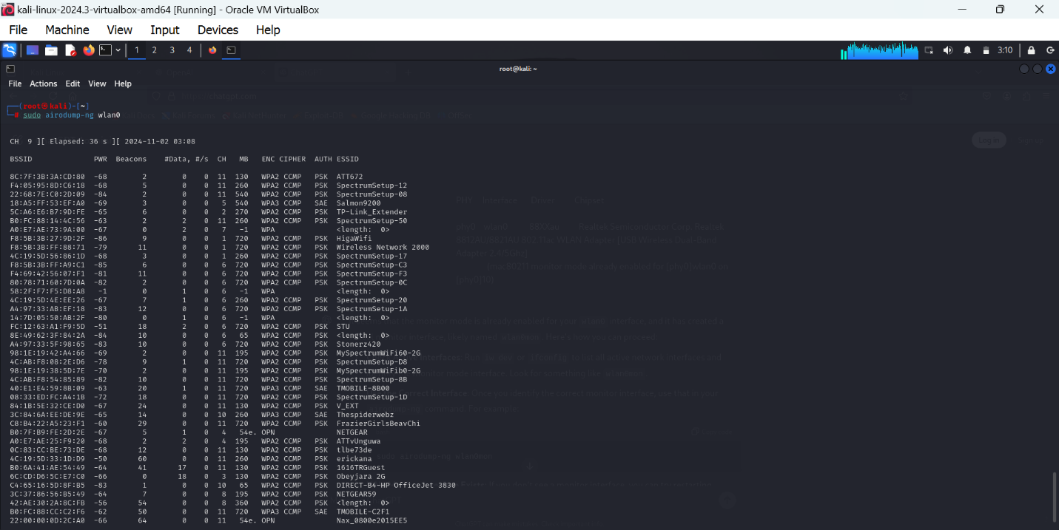

The **BSSID** is a crucial element in wireless networking, helping devices identify and communicate with the correct access points, especially in environments with multiple APs sharing the same SSID. It's useful for both legitimate network management and security testing. Understanding how to collect and analyze BSSIDs is essential for anyone working in wireless network administration, penetration testing, or cybersecurity.

Channel: In Wi-Fi networking, a **channel** refers to a specific frequency range within the radio spectrum that wireless devices use to transmit and receive data. Channels are the building blocks of wireless communication, and they help organize the airwaves to prevent interference between different Wi-Fi networks.

Essid: **ESSID** stands for **Extended Service Set Identifier**. It is the name of a Wi-Fi network and identifies a specific wireless network in an area where multiple networks may exist. The ESSID is typically the **SSID** (Service Set Identifier) but is referred to as **ESSID** when the network spans multiple access points (APs) within a larger wireless network.